Effective Alzheimer's Disease Detection Using Enhanced Xception Blending with Snapshot Ensemble

Chandrakanta Mahanty1, T. Rajesh2, Nikhil Govil3, N. Venkateswarulu4, Sanjay Kumar5, Ayodele Lasisi6, Saiful Islam7, Wahaj Ahmad Khan8*

1Department of CSE, GITAM School of Technology, GITAM Deemed to be University, Visakhapatnam 530045, India; chandra.mahanty@gmail.com

2CSE Deptt., G. Narayanamma Institute of Technology and Science; rajesht531@gmail.com

3 Department of CEA, GLA University, Mathura, U.P., India: nikhil.govil@gla.ac.in

4CSE Department, G. Narayanamma Institute of Technology & Science

(Autonomous) Hyderabad, Telangana, India: [venkateswarulu@gmail.com](mailto:venkateswarulu@gmail.com)

5Professor, Computer Science Department, Galgotias College of Engineering and Technology Greater Noida, [skhakhil@gmail.com](mailto:skhakhil@gmail.com)

6Department of Computer Science, College of Computer Science, King Khalid University, Abha, Saudi Arabia, [alasisi@kku.edu.sa](mailto:alasisi@kku.edu.sa)

7College of Engineering, King Khalid University, Abha 61421, Saudi Arabia

[sfakrul@kku.edu.sa](mailto:sfakrul@kku.edu.sa)

8Institute of Technology, Dire-Dawa University, Dire Dawa 1362, Ethiopia; [wkhan9450@gmail.com](mailto:wkhan9450@gmail.com)

**\*** Correspondence: wkhan9450@gmail.com, chandra.mahanty@gmail.com

**Abstract:** Alzheimer's Disease (AD), a prevalent neurodegenerative disorder, leads to progressive dementia, impairing decision-making, problem-solving, and communication. While there is no cure, early detection can facilitate treatments to slow its progression. DL significantly enhances AD detection by analyzing brain imaging data to identify early biomarkers, improving diagnostic accuracy and predicting disease progression more precisely than traditional methods. In this article, we propose an ensemble methodology for DL models to detect Alzheimer's from brain MRIs, aiding medical practitioners. We trained an enhanced Xception architecture once to produce multiple snapshots, providing diverse insights into MRI features. A decision-level fusion strategy was employed, combining decision scores with a RF meta-learner using a blending algorithm. The efficacy of our ensemble technique is confirmed by the experimental findings, which categorize Alzheimer's into four groups with 99.14% accuracy. This methodology may help medical practitioners provide patients with Alzheimer's with individualized care. Subsequent efforts will concentrate on enhancing the model's efficacy via its generalization to a variety of datasets.

**Keywords:** Alzheimer's Disease; Deep Learning; Brain MRI; Xception; Ensemble; Blending

1. Introduction

AD is a disease that affects the brain by causing deficiencies in memory and several other mental abilities including the abilities to learn, judge, and solve problems. The specific reason for this remains undetermined, however such elements as heredity, surroundings, and life choices are thought to play a role in this process. AD is characterized by the presence of extracellular amyloid plaques and intracellular neurofibrillary tangles which cause brain shrinkage and cell death [1]. According to the National Library of Medicine, approximately 6.5 million Americans aged 65 and older are affected by AD, with projections suggesting this number could reach 13.8 million by 2060 [2]. AD is a common pathology that manifests through memory deficit and disturbances in brain functions which in turn negatively impacts the patient’s daily performance and cognitive functions. It accounts for 60% to 80% of dementia cases, with early detection crucial for timely intervention. The disease leads to difficulties in decision-making, thinking, problem-solving, and communication [3]. AI provides a range of analysis approaches for early diagnosis, drawing from ML models to study the characteristics, indications, and records of diseases [4-5]. More recently, progressive monitoring of patients diagnosed with MCI through neuroimaging has received increased attention for early diagnosis, and MRI has been employed most frequently. It is important that MCI is closely monitored since people diagnosed with this condition have higher chances of developing Alzheimer’s. DL models have shown powerful performance in neuroimaging analytics and have proven to be highly effective in assessing AD progression. Consequently, DL techniques applied to brain MRI have gained immense popularity due to their commendable performance [6-8].

The following stages are typically used to categorize dementia associated with AD [9]:

**Early or Preclinical Stage:** No noticeable cognitive impairment, but significant brain changes like amyloid plaques and tau tangles occur. Detected via biomarkers in cerebrospinal fluid or imaging tests. Normal cognitive functioning is maintained. Early detection and lifestyle changes can delay symptom onset.

**MCI:** Transitional phase between normal aging and dementia with noticeable cognitive changes. Symptoms include memory lapses, difficulty with words, and complex tasks. Independence is maintained with increased effort. Regular monitoring and cognitive therapies can help manage symptoms and slow progression.

**Mild Dementia:** Cognitive decline affects daily life, requiring some support. Symptoms include forgetfulness, confusion, and trouble with finances, planning, and decision-making. Mood changes like depression or irritability may occur. Medications and therapies help maintain independence.

**Moderate Dementia:** Significant cognitive decline requires more support. Symptoms include greater memory loss, difficulty recognizing loved ones, language problems, and personal care challenges. Behavioral changes like wandering and agitation become pronounced. Comprehensive care plans are necessary.

**Severe Dementia:** Profound cognitive decline leads to high dependency. Individuals lose the ability to interact and identify loved ones, with severe memory loss and physical symptoms like difficulty swallowing. Full-time care is needed, often in specialized facilities. Focus shifts to comfort care and quality of life.

DL greatly enhances the diagnosis of AD via the analysis of brain MRI images. It does this by discovering early biomarkers, improving diagnostic accuracy, and forecasting disease progression with higher precision compared to conventional approaches. This technology facilitates timely interventions, individualized treatment strategies, and improved patient results, offering essential assistance to medical professionals. It also faces limitations such as the need for large, high-quality datasets, potential overfitting, and the lack of interpretability of model decisions, which can hinder clinical trust and application.

In our article, we utilized DL techniques in computer-aided detection combined with CNNs trained through TL. We then ensembled the CNNs utilizing a blending method, which significantly decreases computational time and substantially increases prediction accuracy. This approach offers considerable benefits to the medical community.

This article includes the following contributions:

- We utilize TL on enhanced Xception model to forecast and provide decision scores following training on brain MRIs.

- We employ a cosine annealing mechanism to generate many snapshots of the model, each learning different information from the MRIs. This enables us to create base model snapshots for assembly by simply training the CNN model once.

- We utilize these snapshots to build decision scores, which we then feed into an RF meta-learner using the blending algorithm technique.

- We get outstanding results using a large augmented brain MRI dataset of 25,492 samples.

The article is divided into sections: Section 2 reviews relevant work, Section 3 describes the technique, Section 4 presents the findings, and Section 5 includes conclusion.

2. Literature Survey

In recent years, DL methods proved to be beneficial for improving the detection and diagnosis of AD. This literature survey proposes an assessment of the current trends and issues as well as future perspectives related to the use of DL models for the identification of AD.

Massalimova et al. [10] classified AD, moderate cognitive impairment, and normal cognition using MRI and diffusion tensor imaging images from the OASIS-3 dataset using a multimodal DL technique. They unveiled an input-agnostic framework that could diagnose using DTI or MRI images. Their strategy set their method apart from earlier research. Both MRI and DTI scans were utilized to obtain a noteworthy accuracy of 0.96 for their input agnostic model. Using unilateral hippocampal MRI data, Liu et al. [11] created a DL model to forecast the development of moderate cognitive impairment (MCI) to AD dementia. They increased prediction accuracy by combining data from cognitively normal (CN) and AD participants and considering bilateral hippocampus data as independent samples. They found that a major risk factor for AD was left hippocampal degradation. By offering a precise and affordable prediction approach, their model made it possible to stratify MCI patients into subgroups with different chances of AD development. Utilizing AD Neuroimaging Initiative dataset, Saravanakumar et al. [12] constructed a semi-supervised GAN to identify AD. Their approach divided the hippocampus, used a Gaussian filter to remove noise, and identified important characteristics for the diagnosis of AD. Promising for early AD diagnosis and bettering patient quality of life was this novel DL framework. Addressing the problem of lost inter-slice information, Rashid et al. [13] suggested a new architecture dubbed 'Biceph-net' for AD diagnosis utilizing 2D MRI data. Outperforming 2D CNNs and demonstrating computational efficiency, 'Biceph-net' successfully predicted both intra- and inter-slice data. Test accuracy of 100% was obtained for CN versus AD, 98.16% for MCI vs AD, and 97.80% for CN vs MCI vs AD. Its categorization choices were further clarified by a neighborhood-based model interpretation.

Talha et al. [14] improved the early diagnosis of AD by applying DL methods, obtaining high accuracy, low loss, and reliable assessment metrics. Their CNN model obtained 99.11% precision, 0.023% loss, 99.08% f1-score, and 99.19% accuracy. Their multidisciplinary approach aimed to enhance patient outcomes and quality of life and showed notable progress in early AD diagnosis. Utilising the combined powers of the InceptionV3 and ResNet50 architectures, Adhora et al. [15] presented a DL-based method for AD classification. MRI images were preprocessed, a curated dataset was used for training, and predictions from both models were concatenated to increase accuracy. The approach showed the model's capacity to efficiently identify positive and negative situations with an AUC of 85% and sensitivity and accuracy both at 60%. This discovery provided an encouraging method for early AD identification, therefore advancing medical image analysis. Pallawi et al. [16] created a framework for categorizing different AD stages utilizing brain MRI and the EfficientNetB0 model, which was then transferred learning-tuned on a Kaggle dataset. With their method, multi-class Alzheimer's stage was accomplished with 95.78% accuracy. Using MRI images and DL with an improved InceptionV3 model, Jansi et al. [17] predicted Alzheimer's illness. In data preparation, they corrected class imbalance using SMOTE and enhanced generalization by brightness modification. Their method performed 87.69% of the OASIS dataset with accuracy.

Gamal et al. [18] created a new method for diagnosing AD that emphasizes a preprocessing pipeline without registration and addresses data leaking by utilizing only the first patient visit. AUC values of 91.28% for AD vs. MCI and 88.42% for MCI vs. CN tasks were obtained by them using an ensemble learning approach and extensive experimentation on several 3D classification models. Inceptionv3 and DEMNET were used in a hybrid model created by Javid et al. [19] to enhance MRI image-based AD categorization. Class imbalance problem was resolved using the SMOTE mechanism. They beat other tested models with a 98.67% accuracy. Lakhan et al. [20] looked at the burden AD was putting on healthcare systems as its incidence rose. They looked at how DL algorithms and fog and cloud computing may be integrated into digital healthcare systems to address these issues. By their investigation, they found computational obstacles in AD and put forth a new method that uses convex optimization. With this approach, called Evolutionary Deep CNN Scheme, computation time and accuracy limitations in AD diagnosis were optimized. Their simulations showed that, in comparison to earlier research, EDCNNS is more successful in terms of security, deadline adherence, and selection accuracy among various Alzheimer's classes. Using a unique AD-DL methodology combining DL techniques, Sorour et al. [21] concentrated on early AD detection methods. The suggested approach proceeded through phases of pre-processing, DL model training, and assessment using brain MRI data. Five DL models were evaluated, both augmented and non-augmented, and CNN-LSTM outperformed them all with 99.92% accuracy. Leela et al. [22] put out a hybrid EEG and fused CT-MRI based RPCA integrated deep TL model for AD early detection. The model sought to improve classification accuracy by using VGG-19 methods and RPCA, along with data from EEG and fused CT-MRI images. Both updated M-RPCA and fine-tuning the VGG-19 model allowed for feature extraction from fused CT-MRI images and EEG data, respectively. Using DL methods and resting-state fMRI, Alorf et al. [23] investigated multi-label categorization of Alzheimer's phases. The diagnosis of advanced stages of the illness was left undiagnosed by earlier studies, which mostly concentrated on binary categorization. Achieving average accuracy of 77.13% and 84.03%, respectively, the suggested model used Brain Connectivity Graph CNN and Stacked Sparse Autoencoder for classification. Important regions like the precentral gyrus and frontal gyrus were identified using brain region analysis, which also revealed possible biomarkers for the course of Alzheimer's.

Combining Soft-NMS with Faster R-CNN and an enhanced ResNet50 network, Chen et al. [24] presented an ensemble DL model for AD detection. Their model acquired an accuracy of 98.91%. Yao et al. [25] presented Fuzzy-VGG, a new technique that prioritizes important local information in medical pictures to solve AD staging. Fuzzy theory allowed picture pixels to be reordered according to gray levels, which sped up model convergence and enhanced classification accuracy. A two-stage cutoff technique also expanded datasets, improving training outcomes and getting beyond drawbacks of current methods. Sharma et al. [26] looked at the difficulties in identifying AD early on and how it affects people's day-to-day lives. Their work demonstrated accuracies of 90.4% and 71.1% for two datasets, respectively, using DL algorithms on MRI datasets. Two hybrid models for the diagnosis of AD were presented by Ayus et al. [27]: CNN-Conv1D-LSTM and hybrid recurrent ensemble network (HReENet). These models used LSTM as a classifier and CNN as a feature extractor; HReENet combined the projected values of many models. Their efficacy in AD detection was shown by experimental findings that included 99.97% accuracy for HReENet and 98.75% accuracy for CNN-Conv1D-LSTM. Mandawkar et al. [28] combined widely used ML classifiers to develop a Hybrid Cuttle Fish-Grey Wolf Optimization adjusted Ensemble Classifier model for precise AD detection. Fusion parameters of the ensemble classifier were optimized for improved feature extraction by using the hybrid optimization method CUF-GW. The created model is shown to be successful in AD detection with an accuracy of 97.205% for Training Percentage and 97.665% for k-fold analysis in an evaluation on the ADNI database. CNNs and graph attention networks (GATs) are combined by Hasan et al. [29] in a technique for precise neuronal cell segmentation in biological imaging. Context was recorded using a contracting route with max pooling and CLs, and then GATs were used to examine the context. Precise segmentation made possible by the computation of attention coefficients between nodes in the network. Benchmarking methods were surpassed in accuracy of 86.5% and F1 score of 0.719 by the suggested U-GAT algorithm.

Based on the above literature reviews, DL models introduced promising advancements in identifying AD. Although there are issues like limited data availability, simplicity of model interpretation, and high demands on computational resources, they can be further investigated, and solved by new technologies. The use of multi-modal data and creation of explainable AI models are some of the exciting trends of future research.

3. Materials and Methods

3.1. Proposed Framework

In our paper, we utilize DL techniques for computer-aided AD detection, employing CNNs trained via transfer learning. These CNNs are then ensembled using blending, which significantly reduces computational time and enhances prediction accuracy, thereby providing substantial benefits to the medical community. Figure 1 illustrates the steps involved in the proposed framework.

1) Brain MRI images are obtained and subjected to preprocessing.

2) Implement transfer learning by using the enhanced Xception architecture.

3) Generate several snapshots using the CA mechanism (described in Section 3.6) during a single training period.

4) To provide predictions for medical professionals, the classifier ensemble uses a blending technique that integrates many classifiers, including an RF meta-learner.

5) The softmax layer, the final layer, generates the desired output and partitions the input image into one of four categories.

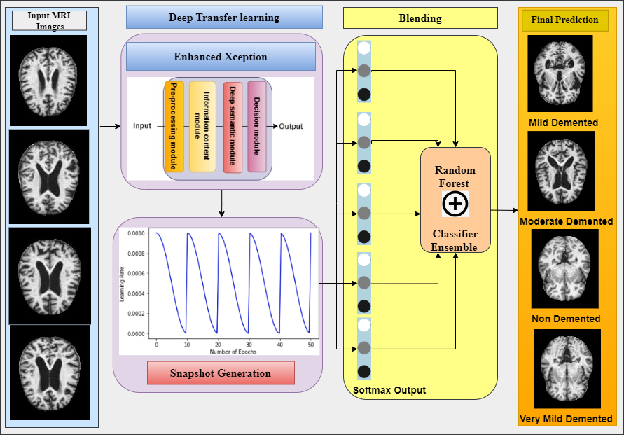

**Figure 1.** Proposed framework for AD detection

3.2. Deep Transfer Learning

3.2.1. Xception

The Xception [30] model, short for "Extreme Inception," is a DL architecture utilizing 14 RBs, each containing a total of 3 common CLs (CCLs) and 33 depthwise separable convolutions. These CCLs are concentrated in the pre-processing module. Designed for computational efficiency and advanced feature extraction, Xception replaces traditional convolutions with depthwise separable convolutions and incorporates residual connections. Adapted for AD detection, it processes medical imaging data like MRI scans to identify disease indicators. The model's decision module uses global average pooling followed by a FCL to make predictions. However, it faces challenges such as high computational cost, large dataset requirements, overfitting risks, and sensitivity to data quality.

3.2.2. Enhanced Xception Model

We have proposed an enhanced Xception model. To mitigate overfitting, we made two key enhancements: removing 4 RBs and incorporating the SE module. Additionally, we replaced each standard CL in the preprocessing module with an IB featuring dilated convolutions and the SE module to capture multi-scale features. We also integrated the FPN to achieve MLF extraction for the final decision.

3.2.3. SE-Residual Block (RB) and SE-Inception Block (IB)

In our technique, the IB is paired with SE module to improve positive FMs while suppressing negative ones. The SE module [31] was introduced for ImageNet categorization. It aims to show feature channel dependency. An SE module has a GPL, two CLL, and an activation layer. The GPL translates individual FM into a feature channel weight value. The weights are communicated across two CLL with ReLU function and normalized to 0-1 utilizing the Sigmoid function. Final calibration involves multiplying the original FM by the normalized weights.

The SE module builds linkages between channels and weights them according to their relevance. Figure 2 (a) shows that the Inception block processes the input × before the SE-module. Here, w $, h, and c$ denote the number of columns, rows, and channels in the FM. The scale action indicates multiplication. This module is also included into the RB to perform the same function. The framework of this combination is seen in Figure 2(b).

3.2.4. Multi-Level Feature [MLF] Extraction Using on FPN

When identifying extremely tiny produced regions, these areas may become indistinguishable or lost in the feature map after several CL and pooling processes, complicating the final judgment. To solve this, FPN [32] is used to extract MLF from both the information content and deep semantic layers. FPN, which utilized effectively in tiny object identification, is combined with GAP and an FCL in our model. As illustrated in Fig. 2(c), the FPN creates FMs at various levels by combining a bottom-up route, a top-down route, and lateral linkages via addition operations. These MLF provide both deep semantic and superficial context information. Each scale's characteristics are then linked to the GAP and FCL. Finally, the data from the various scales are combined to get the ultimate decision.

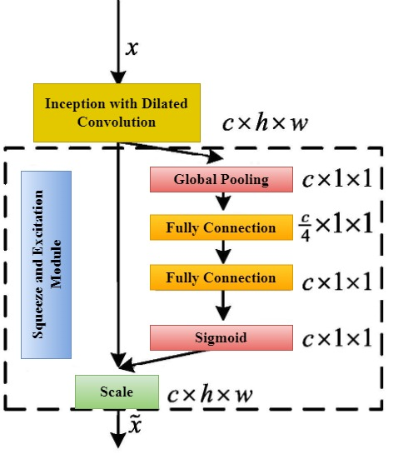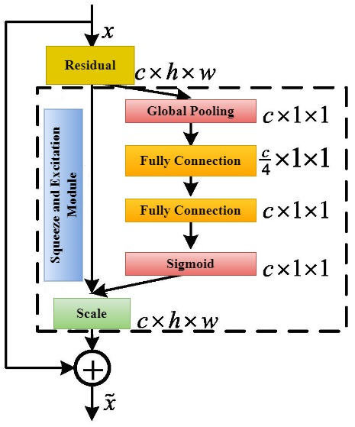

(a) (b)

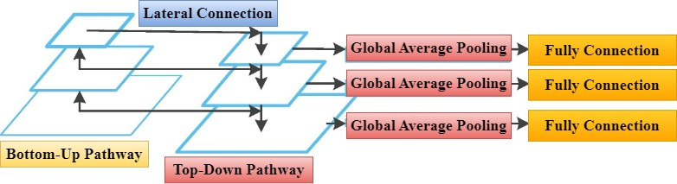

(c)

**Figure 2.** Architecture of (a) SE-IB, (b) SE-RB, (c) FPN connecting with GAP

3.2.5. Framework of the Enhanced Xception

Figure 3 depicts the general framework of the suggested AD detection model. The model is divided into 4 primary modules: preprocessing, information content, deep semantics for feature extraction, and decision module. The network's CL are depthwise separable using a 3 × 3 kernel, with the exception of the preprocessing module, which utilizes the IB. The activation function utilized is called 'elu'. In the pre-processing module, the SE-IB (Figure 3) substitutes the Xception model's normal CL to collect multi-scale characteristics. This block stacks outputs from many CLs with different kernel shapes to improve functionality. The module consists of 2 SE-IBs, each having a CCL and 3 dilated CLs. The kernel counts for these blocks are (6, 10, 10, 6) and (12, 20, 20, 12), with dilation rates of 1, 2, and 3. A common CL with 32 kernels and a stride of 2 reduces image resolution between the SE-IBs.

The information content module utilizes 3 SE-residual pooling blocks with SE-RBs and max-pooling layers to gather inherent image attributes. The kernel counts for the blocks are 128, 256, and 512, and transition CL employs 1×1 kernels with stride 2. The deep semantic module reduces the number of RBs from the original Xception model, thereby preventing overfitting and extracting high-level features. It comprises a depthwise separable CLs with 1024 kernels, 1 SE-RB with 728 kernels, and 4 SE-RBs with 512 kernels each.

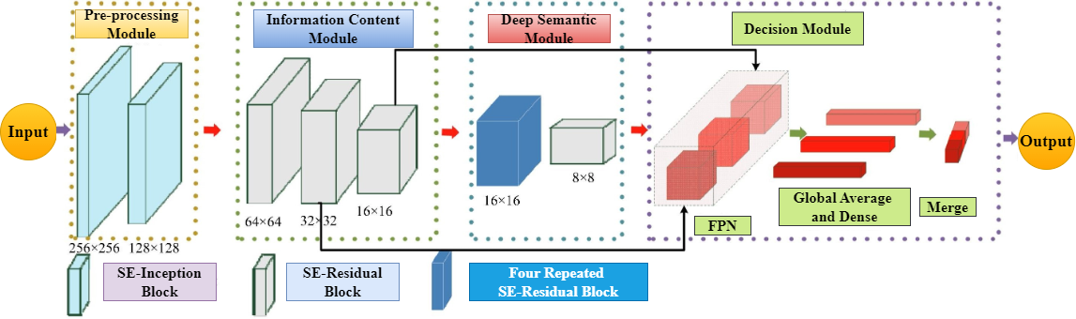

**Figure 3.** Enhanced Xception Model Architecture

In the detailed decision module (Figure 4), MLF maps from 3 layers (resolutions 8×8, 16×16, and 32×32) are used by the FPN for final decision-making. These features are processed through global average pooling and FCLs (16 neurons each), then concatenated for the final softmax classification. The loss function for the entire network is based on cross-entropy, defined as follows:

$$L_{f}= -\sum_{i}{p_{i}}\log\left(y_{i}\right)+\left(1-p_{i}\right)\log\left(1-y_{i}\right)$$

Where, $y_{i}$ and $p_{i}$ denotes actual and predicted label respectively. The decision module's detailed architecture is as follows.

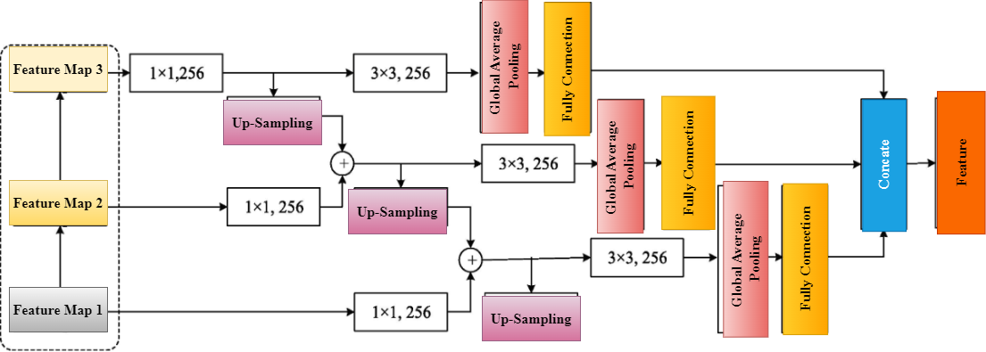

**Figure 4.** Decision module's detailed architecture. Notation $(m × m, n)$ indicates a convolutional layer with a kernel size of $m$ and $n$ kernels.

3.3. Snapshot Ensemble Approach

Training multiple deep neural networks is resource-intensive, posing significant challenges. To address this, Huang et al. [33] recommended a method that generates multiple model snapshots during a single training phase, creating an ensemble without the overhead of training multiple models. This approach involves saving the model parameters at various local minima along the optimization path. Each local minimum represents a set of weights and biases where the model performs reasonably well. By recording these snapshots, they can be ensembled to form a robust model with improved generalization and reduced errors.

3.4. Random Forest

A RF [34] classifier is an ensemble mechanism that constructs multiple DT during training, using random subsets of training data and features, to improve accuracy and robustness. It effectively handles large datasets with high dimensionality, is robust to overfitting, and can manage missing data. RF classifiers also provide insights into feature importance. Utilizing a Boosted RF Classifier can aid in COVID-19 detection on imbalanced datasets while reducing computational resource requirements compared to methods like Snapshot Ensembling [35].

3.5. Blending

DL models exhibit stochastic behavior, capturing diverse information from various local minima during training. To leverage this diversity, an ensemble mechanism can be employed to facilitate information fusion. This mechanism utilizes a blending algorithm to combine classifiers at the decision level. This algorithm operates in 2 stages. In the 1st stage, traditional training is conducted to generate decision scores from multiple base classifiers. Each classifier is trained independently on the training dataset, resulting in a set of decision scores for each instance. In the 2nd stage, these decision scores serve as input features for a meta-learner. The meta-learner is trained to combine these scores into a final prediction. Importantly, the training data used in the 1st stage is distinct from the holdout data utilized for meta-learner training in the 2nd stage. This separation prevents the meta-learner from overfitting, ensuring it generalizes well to unseen data. By combining the strengths of multiple models, the blending algorithm enhances predictive performance and robustness.

***Blending Algorithm***

**Inputs:**

Dataset $D$: The complete dataset, which is divided into:

* $D_{train}$ ​: Training set used to train the base classifiers.
* $D_{hold}$ ​: Hold-out set used to generate predictions for meta-learning.
* $D_{test}$ ​: Test set used to generate final predictions.

**Outputs:**

* $\hat{y}$ ​: The final predicted class for the test dataset.

**Stage 1: Learn Base Classifiers**

1. **For each base classifier $B_{i}$ in the ensemble** :
   * + - * Train $B_{i }$ using the training set $D_{train}$
         * Use $B_{i}$ to make predictions on the hold-out set $D_{hold} ,$ storing these predictions in $D_{S_{i}}$

**Stage 2: Meta-Learning**

2. Train a meta-learner $M$ on the combined predictions $D_{S }$ ​from the hold-out set. This dataset $D_{S }$ ​is composed of the predictions from all base classifiers i.e. $D_{S }$ = { $D_{S_{1}}$, $D_{S_{2}}, {……,D}_{S_{n}}\}$

**Stage 3: Prediction**

3. For each base classifier $B_{i}$ in the ensemble $B$:

* Use $B_{i}$ to make predictions on the test set $D_{test}$, storing these predictions in

4. The meta-learner $M$ then takes the combined predictions $D_{S }$ from the test set and produces the final predicted class $\hat{y}$.

This blending algorithm effectively combines multiple base classifiers to enhance the prediction accuracy by utilizing a meta-learner to learn from the predictions of these base classifiers on a hold-out set. The final step applies the meta-learner to the test set predictions from all base classifiers to produce the final output.

3.6. Cosine Annealing

In order to achieve a satisfactory minimum, SGD frequently necessitates a learning rate (LR) annealing strategy. We implemented a cosine annealing schedule by employing “SGD with Warm Restart (SGDR)” [36] in this investigation. In this method, the LR commences at a high value and progressively decreases in accordance with a cosine function. This approach helps the model to get closer to the global minimum with each batch of training.

The LR $t$, denoted as $α(t)$, decreases according to the following equation 1:

$α\left(t\right)= \frac{α_{0}}{2} \left(cos \frac{π ×mod \left(t-1, \left\lfloor \frac{T}{M}\right\rfloor \right)}{\left\lfloor \frac{T}{M}\right\rfloor }+1\right)$...... Eq. (1)

where: the modulo operation is called $mod$, the floor operation splits the entire epochs into equal cycles, $α\left(t\right)$ represents the LR at epoch $t$, $T$ is the total number of epochs, $α_{0}$ represents the initial (maximum) LR and $M$ is the number of cycles,

The LR is initially set high, then gradually decreases with time with the use of the cosine function to facilitate free movement to the ideal position of the global minimum. This continues for a fixed number of epochs over the data referred to as epochs, allowing the model to reach several local optima. At the end of each cycle, the LR is raised significantly, resulting in a "warm restart." Unlike a "cold restart", which utilizes tiny random numbers to set weights, a "warm restart" uses the excellent weights from the preceding cycle. The high initial LR after a restart aid in the extraction of parameters from the previously converged minimum, enabling the model to explore a new part of the loss landscape and converge to a different local minimum. This frequent, vigorous annealing allows the model to quickly identify better solutions.

Figure 5 illustrates the LR schedule utilized in our article, showing the cyclical nature of the cosine annealing with warm restarts. This technique enhances the model's ability to escape local minima and achieve better overall performance.

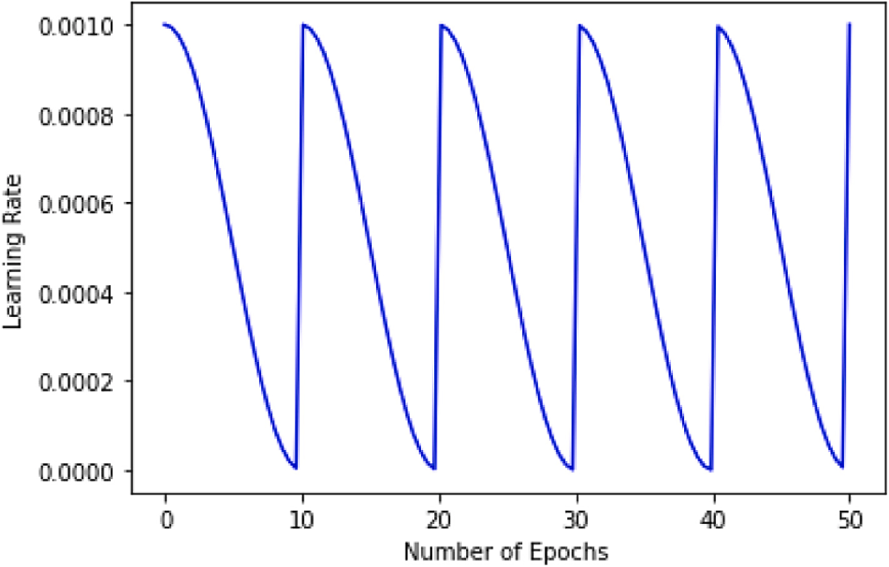

**Figure 5.** Exhibits a cyclical learning rate that adheres to the cosine function and implements a “warm restart” after 10 epochs.

3.7. Generating and Ensembling Snapshots

“Warm restarts” are used in snapshot ensembling to train a single model. This method uses optimization to get the global minimum after visiting numerous local minima. A model snapshot with weights is recorded after a defined number of epochs when it converges to a local minimum. This approach, detailed in prior work, generates an ensemble of distinct models from a single training run. Section 3.3 describes how these snapshots become the basic models for mixing. Diversifying the ensemble models is crucial to their success. Snapshot ensembling uses cosine annealing during training to guarantee the model converges to distinct local minima after each restart. This approach produces many models, which raises the general robustness and performance of the final solution.

3.8. Meta-learner

An RF composes of multiple distinctive DTs that work collectively in a synchronized and integrated manner. Every tree gives its own prediction and the class with the greatest number of such forecasts is taken as the output of the given RF model. This leads to the fact that RF can achieve better results than individual DT as the final decision is made based on the patterns from multiple uncorrelated models.

Once we develop the snapshot models, we use them for prediction on the holdout set and yield decision scores. The concatenated decision scores from the snapshots serve as the input for the next modelThe RF classifier was employed as a meta-learner in this investigation, as part of the blended approach outlined in sub-section 3.5. To avoid overfitting and guarantee generalizability, the meta-learner is trained entirely on the holdout set's decision scores. Once the RF meta-learner is trained, it combines the decision scores to generate the final predictions.

4. Experimental Results and Evaluations

4.1. Description of the dataset

In this article, we utilized the Alzheimer’s dataset [37], a meticulously curated collection of MRI images, verified and labeled by experts. The dataset is readily accessible on Kaggle, offering ease of access in contrast to many other datasets that are often challenging to obtain. This dataset contains 6400 MRI scans with four caterogies.

4.2. Pre-Processing

The brightness of MRI scans was modified by the patient's position in the scanner, his actions, and images from various places, among other things. The bias field is the black-to-white MRI intensity differential. Therefore, image processing requires pretreatment before proceeding. If the bias field is not addressed, all subsequent image processing will be erroneous. Preprocessing methods fix bias field problems and eliminate noise to improve accuracy in the following stages. The Mean RGB colour for MRI and image scaling for colour constancy were calculated in this work. Final MRI pictures were improved by calculating each core pixel based on neighbouring pixels using the averaging filter. All MRIs were resized using DL models. Sample MRI images after enhancement are shown in Figure 6.

4.3. Data Augmentation

DL models need a huge dataset, yet most medical datasets lack images. Creating new photos from the same dataset solves the issue. Overfitting occurs when the dataset is small owing to a lack of training data. The data augmentation approach generates visuals during training. This research uses an uneven MRI dataset. Increasing the minority dataset class size with augmentation balanced the dataset and solved the overfitting issue. The minority class dataset was supplemented during training using Rotation, Cropping, Flipping, Brightness, and Contrast Augmentation. Other categories have 64 more photos than mild dementia. Thus, more data augmentations were used than in other categories. Table 1 illustrates MRI dataset before and after data augmentation. Without data augmentation, overfitting will occur owing to a lack of data during training, resulting in poor diagnostic outcomes. Without this method, an imbalanced data collection has poor diagnostic accuracy. Table 1 shows the MRI dataset split.

**Table 1.** shows the data augmentation strategy used to balance the MRI dataset throughout the training and testing phase.

|  |  |  |  |  |
| --- | --- | --- | --- | --- |
| Name of Class | Non-Demented | Moderate Demented | Mild Demented | Very Mild Demented |
| Before augmentation | 3200 | 64 | 896 | 2240 |
| After augmentation (Training) | 6600 | 6200 | 6272 | 6420 |
| Testing | 640 | 12 | 179 | 448 |

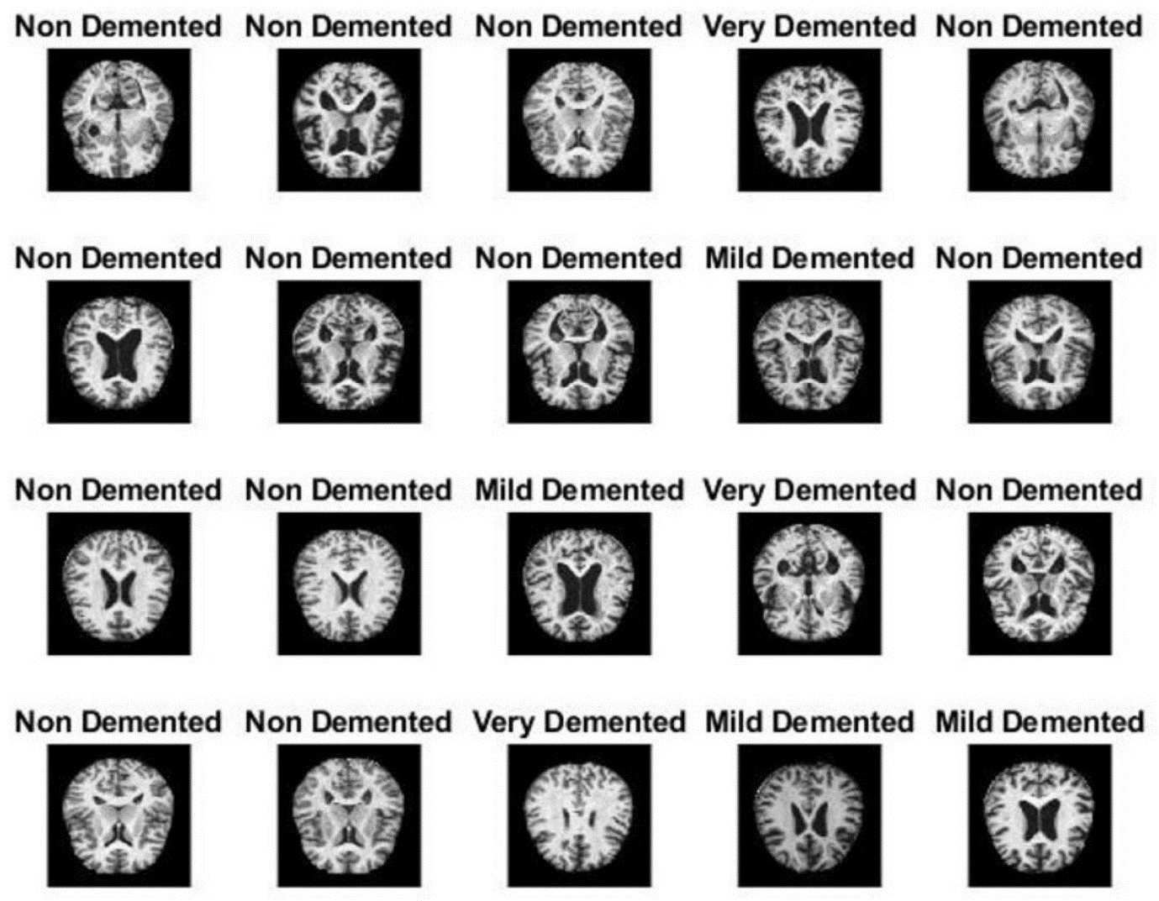

**Figure 6.** Sample MRIs after image enhancement

4.4. Experimental Design

The suggested framework was developed using Python 3.6 and PyCharm on a Windows 11 operating system. The testing setup utilized an 8 GB RAM GPU running the Keras DL architecture and included the Scipy, Numpy, and openCV libraries. The networks are optimized for 25 epochs using Adam optimizer with a LR of 0.0001 and ReLU activation functions. Figure 4 shows the accuracy and loss curves achieved by the DenseNet-201 model during training. The proposed model's performance was assessed based on performance metrices, with the findings displayed in Figure 5. The confusion matrix for DenseNet-201 is seen in Figure 6. The performance metrics were calculated using the following formulae. We implemented the base classifiers using the TensorFlow library in Python. Our TL model is trained with SGD algorithm, with a momentum value of 0.9 and an initial LR of 0.0001. The training process spans 100 epochs, during which we save snapshots of the model weights every 10 epochs, resulting in 10 snapshot models. These snapshot models are then employed as base models in the previously described blending mechanism. For the meta-learner, we used SciKit-Learn. The hyperparameters for both the base classifiers and the meta-learner were determined through experimental optimization. For RF classifier method using the AD MRI dataset, we configured the parameters as follows: the number of DT $(n_estimatorsn_estimators)$ is set to $900$, the minimum number of data points in a leaf node $(min_samples_leafmin_samples_leaf)$ is 1, the minimum number of data points required to split a node $(min_samples_splitmin_samples_split)$ is $10$, and the maximum number of levels per DT $(max_depthmax_depth)$ is $4$.

4.5. Analysis

Figure 8 shows the blended ensembling confusion matrices for the 4-class classification task on the AD MRI dataset. Figure 7 shows the performance of snapshots, or basic models, created every 10 epochs on each dataset's test sets. The suggested method's class-wise performance on AD MRI datasets is shown in Table 2. Figure 8's confusion matrices show that our technique precisely identifies images. Figure 7 also displays base model beginning performance on MRI dataset. Confusion matrices show that our blended ensembling strategy improves prediction accuracy. This significant increase in accuracy highlights the effectiveness of our suggested method. Table 2 lists the performance metrics that we calculated using the following formulas.

1. $Precision=\frac{True Positive (TP)}{True Positive+False Positive (FP)}$

2. $Sensitivity or Recall=\frac{True Positive}{True Positive+False Negative (FN)}$

3. $F1-Score=\frac{2 x(Precision x Recall)}{(Precision+ Recall)}$

4. $Specificity=\frac{True Negative (TN)}{True Negative+False Positive}$

5. $Accuracy=\frac{TP+TN}{TP+ TN+ FP+FN}$

The confusion matrix for the AD MRI dataset reveals the performance of the classification model across four categories. For the Mild Demented category, the model correctly predicted 176 instances, with minimal misclassifications, only confusing 1 as Moderate Demented and 2 as Non-Demented. The Moderate Demented category had 11 correct predictions, with slight confusion leading to 1 misclassification each into Mild Demented and Very Mild Demented. Non-Demented cases were predicted with high accuracy, with 636 correct predictions and only 2 misclassifications as Mild Demented, 1 as Moderate Demented, and 1 as Very Mild Demented. Lastly, the Very Mild Demented category saw 445 correct predictions, with minor misclassifications into Mild Demented and Moderate Demented categories, each having 2 and 1 misclassifications respectively. Overall, the model demonstrates strong performance, particularly in accurately predicting Non-Demented cases, while showing some confusion among the Mild and Very Mild Demented categories.

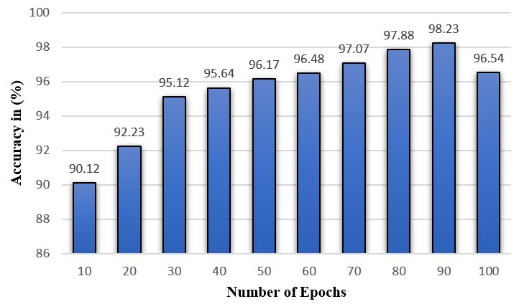

**Figure 7.** Performance of base CNN classifiers

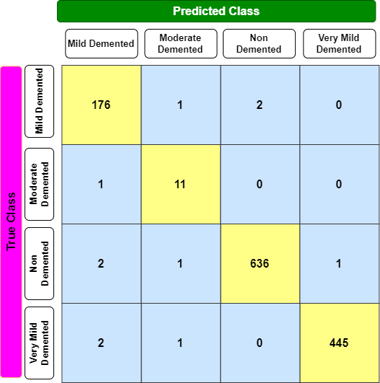

**Figure 8.** Confusion Matrix

**Table 2.** Performance evaluation results on 4-class AD MRI datasets

|  |  |  |  |
| --- | --- | --- | --- |
| **Class Name** | **Precision** | **Recall** | **f1-score** |
| Mild Demented | 0.9832 | 0.9724 | 0.9778 |
| Moderate Demented | 0.9167 | 0.7857 | 0.8462 |
| Non Demented | 0.9938 | 0.9969 | 0.9953 |
| Very Mild Demented | 0.9933 | 0.9978 | 0.9955 |
| **Accuracy** | 99.14 % | | |
| **Misclassification Rate** | 00.86 % | | |
| **Macro-F1** | 0.9537 | | |
| **Weighted-F1** | 0.9913 | | |

The results mentioned in Table 2 collectively highlight the model's capability to accurately classify AD based on Brain MRI images. Multiple assessment criteria showed outstanding performance results for the suggested approach. The model accurately predicts outcomes with 99.14% accuracy and 0.86% inaccuracy. The model performs well across all classes with a macro-F1 score of 0.9537, demonstrating its versatility in diagnostic contexts. The weighted-F1 score of 0.9913 shows its efficiency in resolving medical dataset class imbalances. These results imply that the model has good accuracy, precision, and recall for imaging-based AD diagnosis. To demonstrate proposed model performance, we randomly selected brain MRI images from the dataset, input these images into the model, and obtained the outputs as reflected in Figure 9.

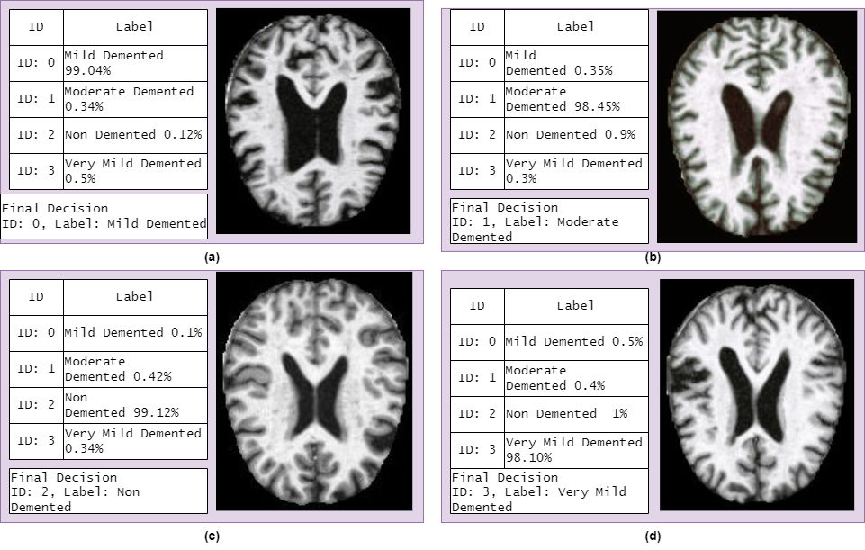

**Figure 9.** Examples of (a) Mild Demented, (b) Moderate Demented, (c) Non Demented and (d) Very Mild Demented identification utilizing a randomly selected test image

**Table 3.** Various DL model performance against the suggested model on the same AD dataset [37].

|  |  |  |  |
| --- | --- | --- | --- |
| **Authors** | **Models** | **Optimizer** | **Accuracy (%)** |
| Suganthe et al. [38] | Inception and ResNet V2 | RMS Prop | 79.12 |
| Pradhan et al. [39] | VGG19 | Adam | 84.71 |
| Sharma et al. [26] | VGG16 | Adam | 90.40 |
| [Mohammed](https://scholar.google.com/citations?user=fYJ5mDQAAAAJ&hl=en&oi=sra) et al. [40] | AlexNet+SVM | Adam | 94.80 |
| Fu'adah et al. [41] | AlexNet | Adam | 95.00 |
| Murugan et al. [42] | DEMNET | RMS prop | 95.23 |
| Hao et al. [43] | CNN+NN | Adam | 95.90 |
| Alhamidi et al. [44] | MobileNet and CNN | SGD | 95.92 |
| Isunuri et al. [45] | EfficientNetB4 and separable convolution block | Adam | 97.32 |
| Alhudhaif et al. [46] | DL model with Focal Dice Loss function | Adam | 98.20 |
| Khatun et al. [47] | VGG + LSTM | Adam | 98.80 |
| Kim et al. [48] | Hybrid Quantum ResNet-18 | Adam | 98.90 |
| Vashishtha et al. [49] | Inception V3 and Resnet50 | Adam | 99.00 |
| **Proposed Model** | **Enhanced Xception with Blending Algorithm** | **Adam** | **99.14** |

5. Conclusions

In developed countries, AD is a leading cause of death. It is very difficult to make an early diagnosis, but using computer methods Along with medical knowledge and findings provides the best solution. In the recent past, DL has shown a high level of efficiency in predicting the progression of AD using neuroimaging data and hence slowing down the progression of the disease. In this article, we described a valid approach to building an ensemble of DL models for the detection of AD utilizing MRI images of the human brain. In this work, we used transfer learning on an improved Xception model; we generated several snapshots during the training phase using a cosine annealing learning rate schedule, which allowed the segmentation of various characteristics of the MRIs. These snapshots were then fused at the decision level by synthesizing with a RF meta-learner through blending algorithm. In our case our proposed approach yielded a high performance on the large augmented brain MRI dataset of 25,492 samples. Achieving a classification accuracy of 99.14% and a low misclassification rate of 0.86%, the model shows high precision and reliability in predicting AD. The macro-F1 score of 0.9537 indicates strong, consistent performance across all classes, while the weighted-F1 score of 0.9913 highlights its efficacy in managing class imbalances typically seen in medical datasets. These results validate the effectiveness of our ensemble method, suggesting significant potential benefits for the medical community in early detection and customized treatment of AD. Larger volumes of data will be gathered and assessed in the future to enable the fast and accurate diagnosis of Alzheimer's patients and to mix different kinds of data to improve the detection models' precision.

**Author Contributions:** Conceptualization, C.M, S.G.K.P. and S.K.; methodology, C.M. and A.L.; software, C.M.; validation, and S.G.K.P and S.I.; formal analysis, C.M. and W.A.K.; investigation; resources; data curation, S.G.K.P. and A.L.; writing—original draft preparation, C.M. and S.I.; writing—review and editing, C.M. and S.K; visualization. All authors have read and agreed to the published version of the manuscript.

**Data Availability Statement:**

Alzheimer's Dataset (4 class of Images) Brain MRI scans are available from Kaggle:

<https://www.kaggle.com/datasets/tourist55/alzheimers-dataset-4-class-of-images>

**Conflicts of Interest:** No conflicts of interest.

**ABBREVIATION**

|  |  |
| --- | --- |
| AD | Alzheimer's Disease |
| AI | Artificial Intelligence |
| CA | Cosine Annealing |
| CCL | Common Convolution Layer |
| CL | Convolution Layer |
| CNN | Convolutional Neural Network |
| DL | Deep Learning |
| DT | Decision Trees |
| FM | Feature Map |
| FCL | Fully Connected Layer |
| FPN | Feature Pyramid Network |
| GAL | Global Average Pooling |
| GAN | Generative Adversarial Networks |
| GPL | Global Pooling Layer |
| IB | Inception Block |
| LL | Linked Layers |
| LR | Learning Rate |
| LSTM | Long Short-Term Memory |
| MCI | Mild Cognitive Impairment |
| ML | Machine Learning |
| MLF | Multi-Level Feature |
| MRI | Magnetic Resonance Imaging |
| RB | Residual Block |
| RF | Random Forest |
| SE | Squeeze and Excitation |
| SGD | Stochastic Gradient Descent |

References

1. Blennow, Kaj, Mony J. de Leon, and Henrik Zetterberg. "Alzheimer's disease." The Lancet 368, no. 9533 (2006): 387-403.
2. Cummings, Jeffrey, Garam Lee, Pouyan Nahed, Mina Esmail Zadeh Nojoo Kambar, Kate Zhong, Jorge Fonseca, and Kazem Taghva. "Alzheimer's disease drug development pipeline: 2022." Alzheimer's & Dementia: Translational Research & Clinical Interventions 8, no. 1 (2022): e12295.
3. Scheltens, Philip, Bart De Strooper, Miia Kivipelto, Henne Holstege, Gael Chételat, Charlotte E. Teunissen, Jeffrey Cummings, and Wiesje M. van der Flier. "Alzheimer's disease." The Lancet 397, no. 10284 (2021): 1577-1590.
4. Yang, Kuo, and Emad A. Mohammed. "A review of artificial intelligence technologies for early prediction of Alzheimer's disease." arXiv preprint arXiv:2101.01781 (2020).
5. Battista, Petronilla, Christian Salvatore, Manuela Berlingeri, Antonio Cerasa, and Isabella Castiglioni. "Artificial intelligence and neuropsychological measures: The case of Alzheimer’s disease." Neuroscience & Biobehavioral Reviews 114 (2020): 211-228.
6. Liu, Siqi, Sidong Liu, Weidong Cai, Sonia Pujol, Ron Kikinis, and Dagan Feng. "Early diagnosis of Alzheimer's disease with deep learning." In 2014 IEEE 11th international symposium on biomedical imaging (ISBI), pp. 1015-1018. IEEE, 2014.
7. Khojaste-Sarakhsi, M., Seyedhamidreza Shahabi Haghighi, SMT Fatemi Ghomi, and Elena Marchiori. "Deep learning for Alzheimer's disease diagnosis: A survey." Artificial intelligence in medicine 130 (2022): 102332.
8. Warren, Samuel L., and Ahmed A. Moustafa. "Functional magnetic resonance imaging, deep learning, and Alzheimer's disease: A systematic review." Journal of Neuroimaging 33, no. 1 (2023): 5-18.
9. Kalaria, Raj. "Similarities between Alzheimer's disease and vascular dementia." Journal of the neurological sciences 203 (2002): 29-34.
10. Massalimova, Aidana, and Huseyin Atakan Varol. "Input agnostic deep learning for Alzheimer’s disease classification using multimodal MRI images." In 2021 43rd Annual International Conference of the IEEE Engineering in Medicine & Biology Society (EMBC), pp. 2875-2878. IEEE, 2021.
11. Liu, Xi, Hongming Li, and Yong Fan. "Predicting Alzheimer’s Disease and Quantifying Asymmetric Degeneration of the Hippocampus Using Deep Learning of Magnetic Resonance Imaging Data." In 2023 IEEE 20th International Symposium on Biomedical Imaging (ISBI), pp. 1-4. IEEE, 2023.
12. Saravanakumar, S., and T. Saravanan. "Early Alzheimer’s Disease Detection Using Semi-Supervised GAN Based on Deep Learning." In 2022 IEEE VLSI Device Circuit and System (VLSI DCS), pp. 194-198. IEEE, 2022.
13. Rashid, Ashraf Haroon, Aditya Gupta, Jhalak Gupta, and Mohammad Tanveer. "Biceph-Net: A robust and lightweight framework for the diagnosis of Alzheimer's disease using 2D-MRI scans and deep similarity learning." IEEE Journal of Biomedical and Health Informatics 27, no. 3 (2022): 1205-1213.
14. Talha, Abdul, Ch Dhanasree, E. Divya, Kandagatla Srikar Prabhas, and U. Syed Abudhagir. "Performance Evaluation of Deep Learning Models for Alzheimer’s Disease Detection." In 2024 10th International Conference on Communication and Signal Processing (ICCSP), pp. 317-322. IEEE, 2024.
15. Adhora, Nazifa Rahman, Shyla Afroge, Kollol Kumar, and Mir Safwan Marzouq. "Deep Learning Based Feature Fusion Model for Classifying Alzheimer’s Disease Using Brain MRI Images." In 2023 26th International Conference on Computer and Information Technology (ICCIT), pp. 1-6. IEEE, 2023.
16. Pallawi, Shruti, and Dushyant Kumar Singh. "Detection of Alzheimer's Disease Stages Using Pre-Trained Deep Learning Approaches." In 2023 IEEE 5th International Conference on Cybernetics, Cognition and Machine Learning Applications (ICCCMLA), pp. 252-256. IEEE, 2023.
17. Jansi, R., Naraganti Gowtham, Siva Ramachandran, and V. Sai Praneeth. "Revolutionizing Alzheimer's Disease Prediction using InceptionV3 in Deep Learning." In 2023 7th International Conference on Electronics, Communication and Aerospace Technology (ICECA), pp. 1155-1160. IEEE, 2023.
18. Gamal, Aya, Mustafa Elattar, and Sahar Selim. "Automatic early diagnosis of Alzheimer’s disease using 3D deep ensemble approach." IEEE Access 10 (2022): 115974-115987.
19. Javid, Sajjad Aghasi, and Mahmood Mohassel Feghhi. "Early diagnosis of Alzheimer’s disease from MRI images with deep learning model." In 2024 20th CSI International Symposium on Artificial Intelligence and Signal Processing (AISP), pp. 1-5. IEEE, 2024.
20. Lakhan, Abdullah, Tor-Morten Grønli, Ghulam Muhammad, and Prayag Tiwari. "EDCNNS: Federated learning enabled evolutionary deep convolutional neural network for Alzheimer disease detection." Applied Soft Computing 147 (2023): 110804.
21. Sorour, Shaymaa E., Amr A. Abd El-Mageed, Khalied M. Albarrak, Abdulrahman K. Alnaim, Abeer A. Wafa, and Engy El-Shafeiy. "Classification of Alzheimer’s disease using MRI data based on Deep Learning Techniques." Journal of King Saud University-Computer and Information Sciences 36, no. 2 (2024): 101940.
22. Leela, M., K. Helenprabha, and L. Sharmila. "Prediction and classification of Alzheimer disease categories using integrated deep transfer learning approach." Measurement: Sensors 27 (2023): 100749.
23. Alorf, Abdulaziz, and Muhammad Usman Ghani Khan. "Multi-label classification of Alzheimer's disease stages from resting-state fMRI-based correlation connectivity data and deep learning." Computers in Biology and Medicine 151 (2022): 106240.
24. Chen, Yusi, Lizhen Wang, Bijiao Ding, Jianshe Shi, Tingxi Wen, Jianlong Huang, and Yuguang Ye. "Automated Alzheimer's disease classification using deep learning models with Soft-NMS and improved ResNet50 integration." Journal of Radiation Research and Applied Sciences 17, no. 1 (2024): 100782.
25. Yao, Zhaomin, Wenxin Mao, Yizhe Yuan, Zhenning Shi, Gancheng Zhu, Wenwen Zhang, Zhiguo Wang, and Guoxu Zhang. "Fuzzy-VGG: A fast deep learning method for predicting the staging of Alzheimer's disease based on brain MRI." Information Sciences 642 (2023): 119129.
26. Sharma, Shagun, Kalpna Guleria, Sunita Tiwari, and Sushil Kumar. "A deep learning based convolutional neural network model with VGG16 feature extractor for the detection of Alzheimer Disease using MRI scans." Measurement: Sensors 24 (2022): 100506.
27. Ayus, Ishan, and Deepak Gupta. "A novel hybrid ensemble based Alzheimer’s identification system using deep learning technique." Biomedical Signal Processing and Control 92 (2024): 106079.
28. Mandawkar, Umakant, and Tausif Diwan. "Hybrid cuttle Fish-Grey wolf optimization tuned weighted ensemble classifier for Alzheimer’s disease classification." Biomedical Signal Processing and Control 92 (2024): 106101.
29. Hasan, Md Easin, and Amy Wagler. "A novel deep learning graph attention network for Alzheimer’s disease image segmentation." Healthcare Analytics (2024): 100310.
30. Chollet, François. "Xception: Deep learning with depthwise separable convolutions." In Proceedings of the IEEE conference on computer vision and pattern recognition, pp. 1251-1258. 2017.
31. Hu, Jie, Li Shen, and Gang Sun. "Squeeze-and-excitation networks." In Proceedings of the IEEE conference on computer vision and pattern recognition, pp. 7132-7141. 2018.
32. Lin, Tsung-Yi, Piotr Dollár, Ross Girshick, Kaiming He, Bharath Hariharan, and Serge Belongie. "Feature pyramid networks for object detection." In Proceedings of the IEEE conference on computer vision and pattern recognition, pp. 2117-2125. 2017.
33. Huang, Gao, Yixuan Li, Geoff Pleiss, Zhuang Liu, John E. Hopcroft, and Kilian Q. Weinberger. "Snapshot ensembles: Train 1, get m for free." arXiv preprint arXiv:1704.00109 (2017).
34. Breiman, Leo. "Random forests." Machine learning 45 (2001): 5-32.
35. Iwendi, Celestine, Ali Kashif Bashir, Atharva Peshkar, R. Sujatha, Jyotir Moy Chatterjee, Swetha Pasupuleti, Rishita Mishra, Sofia Pillai, and Ohyun Jo. "COVID-19 patient health prediction using boosted random forest algorithm." Frontiers in public health 8 (2020): 357.
36. Loshchilov, Ilya, and Frank Hutter. "Sgdr: Stochastic gradient descent with warm restarts." arXiv preprint arXiv:1608.03983 (2016).
37. "Alzheimer's Dataset (4 class of Images) Brain MRI".[online] https://www.kaggle.com/datasets/tourist55/alzheimers-dataset-4-class-of-images [accessed on 6th May 2024]
38. Suganthe, R. C., M. Geetha, G. R. Sreekanth, K. Gowtham, S. Deepakkumar, and R. Elango. "Multiclass classification of Alzheimer’s disease using hybrid deep convolutional neural network." NVEO-NATURAL VOLATILES & ESSENTIAL OILS Journal| NVEO (2021): 145-153.
39. Pradhan, Amnaya, Jerin Gige, and M. Eliazer. "Detection of Alzheimer’s disease (AD) in MRI images using deep learning." Int. J. Eng. Res. Technol 10, no. 3 (2021): 580-585.
40. Mohammed, Badiea Abdulkarem, Ebrahim Mohammed Senan, Taha H. Rassem, Nasrin M. Makbol, Adwan Alownie Alanazi, Zeyad Ghaleb Al-Mekhlafi, Tariq S. Almurayziq, and Fuad A. Ghaleb. "Multi-method analysis of medical records and MRI images for early diagnosis of dementia and Alzheimer’s disease based on deep learning and hybrid methods." Electronics 10, no. 22 (2021): 2860.
41. Fu’Adah, Y. N., I. Wijayanto, N. K. C. Pratiwi, F. F. Taliningsih, S. Rizal, and M. A. Pramudito. "Automated classification of Alzheimer’s disease based on MRI image processing using convolutional neural network (CNN) with AlexNet architecture." In Journal of physics: conference series, vol. 1844, no. 1, p. 012020. IOP Publishing, 2021.
42. Murugan, Suriya, Chandran Venkatesan, M. G. Sumithra, Xiao-Zhi Gao, B. Elakkiya, Muthuramalingam Akila, and S. Manoharan. "DEMNET: a deep learning model for early diagnosis of Alzheimer diseases and dementia from MR images." Ieee Access 9 (2021): 90319-90329.
43. Hao, Yi, Cheng Pengzhou, Feng Moyuan, and Teoh Teik Toe. "Alzheimer's Disease Image Classification Based on Efficient Convolutional Neural Network." In Proceedings of the 2022 7th International Conference on Biomedical Imaging, Signal Processing, pp. 6-11. 2022.
44. Alhamidi, Mais. "Detection of Alzheimer's Disease using deep learning algorithm." Advanced Engineering Days (AED) 7 (2023): 44-46.
45. Isunuri, Bala Venkateswarlu, and Dr Jagadeesh Kakarla. "Alzheimer’s severity classification using Transfer Learning and Residual Separable Convolution Network." In Proceedings of the Thirteenth Indian Conference on Computer Vision, Graphics and Image Processing, pp. 1-6. 2022.
46. Alhudhaif, Adi, and Kemal Polat. "Residual block fully connected DCNN with categorical generalized focal dice loss and its application to Alzheimer’s disease severity detection." PeerJ Computer Science 9 (2023): e1599.
47. Khatun, Maleka, Md Manowarul Islam, Habibur Rahman Rifat, Md Shamim Bin Shahid, Md Alamin Talukder, and Md Ashraf Uddin. "Hybridized Convolutional Neural Networks and Long Short-Term Memory for Improved Alzheimer’s Disease Diagnosis from MRI Scans." In 2023 26th International Conference on Computer and Information Technology (ICCIT), pp. 1-6. IEEE, 2023.
48. Kim, Ryan. "Hybrid Quantum-Classical Machine Learning for Dementia Detection." In 2023 IEEE MIT Undergraduate Research Technology Conference (URTC), pp. 1-5. IEEE, 2023.
49. Vashishtha, Anuradha, A. K. Acharya, and S. Swain. "Hybrid Model: Deep Learning method for Early Detection of Alzheimer's disease from MRI images." Biomedical and Pharmacology Journal 16, no. 3 (2023): 1617-1630.